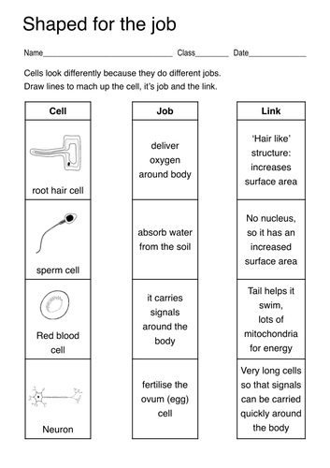
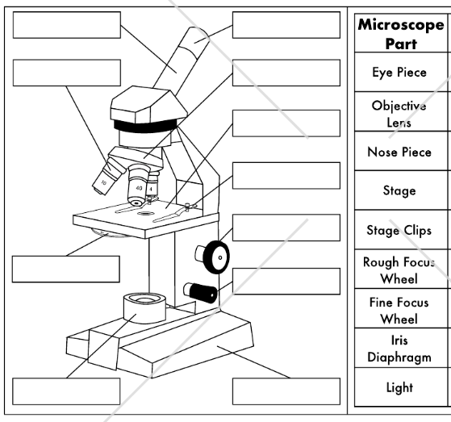
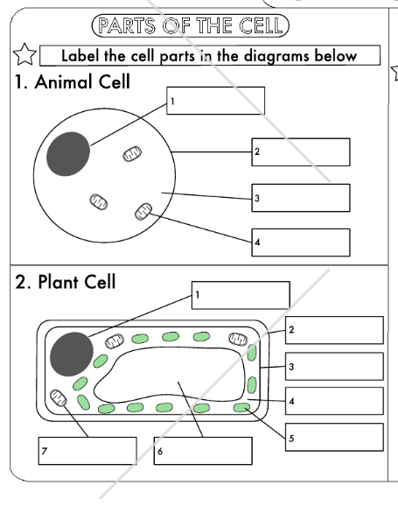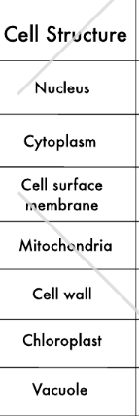

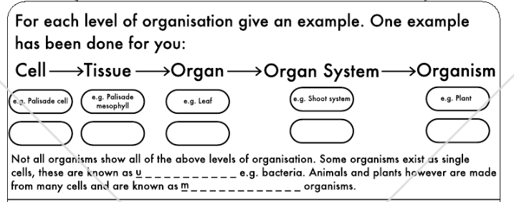

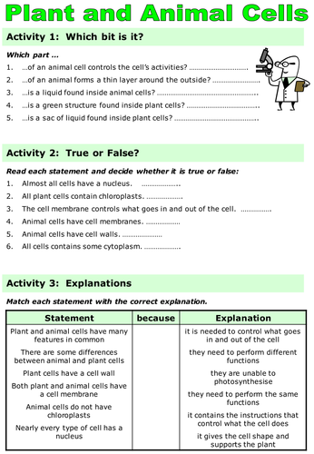

Golgi body
Mitochondria
Rough endoplasmic reticulum
Draw the following organelles:

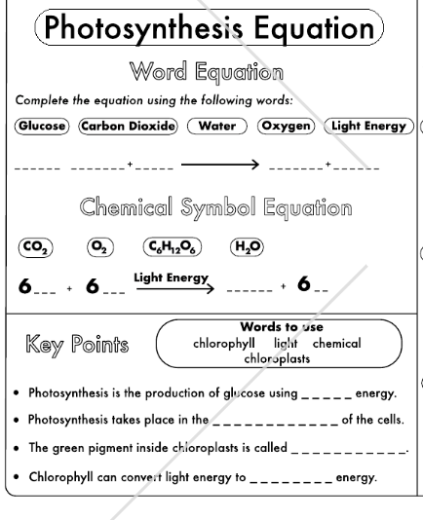
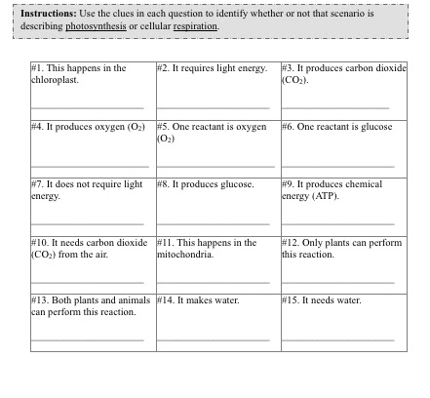

Pictionary:
Mitochondria
Golgi body
Endoplasmic reticulum
DNA
Respiration
Photosynthesis
Animal cell
Plant cell
Microscope
Tissue
Organ
Organ system
Multicellular
Unicellular

